Guidelines for surveillance of invasive mosquitoes in Europe

How to implement invasive-mosquito surveillance on the basis of mosquito-borne diseases risk in a country/region

To start, follow the flow and click on the higlighted boxes in the figure below [purple rectangles].
Or use the left menu to go to a particular step.

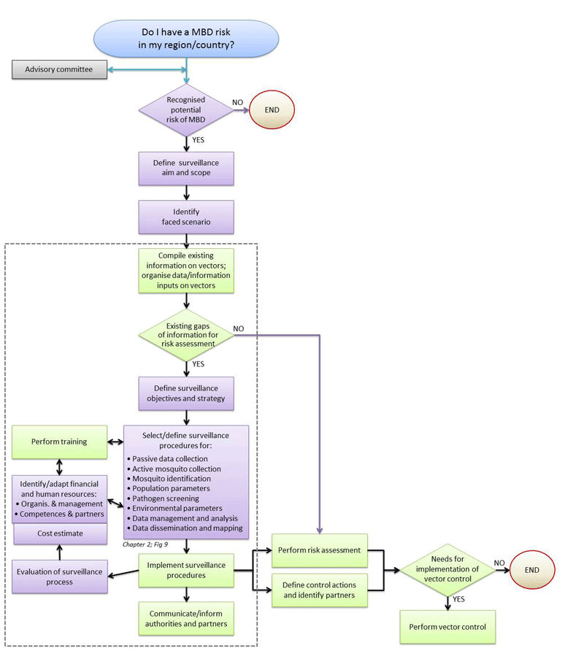
- See more at: http://ecdc.europa.eu/en/healthtopics/vectors/surveillance-invasive-mosquitoes/Pages/guidelines.aspx#sthash.zVRGkuKR.dpuf

